DASHBOARD GUIDE
M1/M2 is displayed here (raised button)
Attached Image
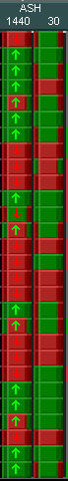
GAP is displayed here (Absolute Strength gap).... not CRS-Cumulative Relative Strength 'gap'
Attached Image
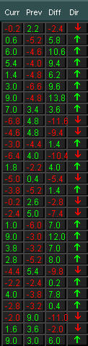
CRS-Cumulative Relative Strength current 'value' is displayed here
(CRS gap 'difference' & direction (from previous value) is displayed by arrow..
YOU control 'buffer' on arrow 'change'. YOU control value 'updating'. YOU control previous 'candle agreement')
Attached Image
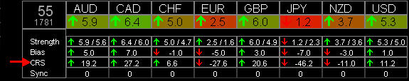
HP-- correct if mixed up
Flexi filters fi. bidratio are based on the average above and below a cutoff point trying to follow the market a bid more.
Fi. buy bidratio average is all of the 28 bidratios above 65% divided by the number of.
If the bidratio for a certain pair goes above that average it is seen as a signal instead of using a fixed value of 80 or 90%.
Same goes for Relative strength and buy/sell ratio.
I added a selectable percentage for each value (in %) in case you get to much (go to 110%) or to few (go to 90%) signals.
(would leave it at 100% for now until i tested it).
This is to 'help'... not 'explain' all.
You basically look/analyze this ENTIRE BLOCK...
to
discern WHY a trade is NOT happening (yet)....
to help determine:
what/why you might want change: eliminate/add or increase/decrease in auto settings.
Attached Image
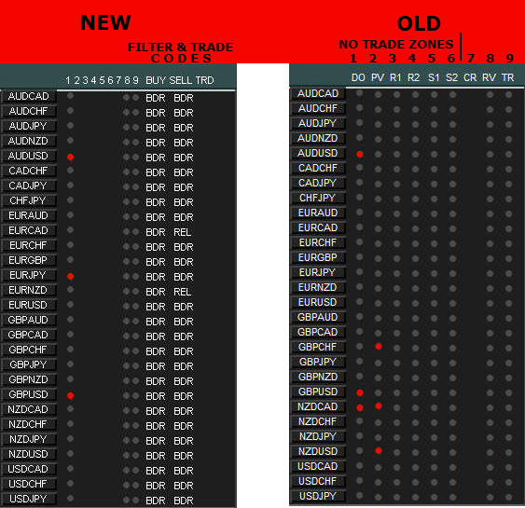
Steps to calculate the relative strength:
1. calculate the Pip Range from high / low of each pair
2. calculate the Bid Ratio: (BID - LOW) / Pip Range
3. Get the equivalent value of the result from this table
if (bid_ratio >= 0.97) ind_strength = 9; else
if (bid_ratio >= 0.90) ind_strength = 8; else
if (bid_ratio >= 0.75) ind_strength = 7; else
if (bid_ratio >= 0.60) ind_strength = 6; else
if (bid_ratio >= 0.50) ind_strength = 5; else
if (bid_ratio >= 0.40) ind_strength = 4; else
if (bid_ratio >= 0.25) ind_strength = 3; else
if (bid_ratio >= 0.10) ind_strength = 2; else
if (bid_ratio >= 0.03) ind_strength = 1;
which becomes the value for relative strength.
Example AUDCAD:
Pip Range = 52
Bid Ratio = 0.72 (72%)
Relative Strength of AUDCAD is 6:3 (AUD = 6, CAD = 3 (9 - 6))
I hope it's understandable!
Jibala
SETS Wrapping you head around the new V3P and set files...
We now have SO many (flexi accurate) variables to play with...
fi.. you can go 'pure' and stay with (just) Bid Ratio to enter/exit OR CRM to enter/exit OR GAP to enter/exit OR RSI to enter/exit OR ASH.. or, or, or...
then
each of those 'pure' methods have their own VALUES to be dialed in... which can (even) be different for entry vs. exit.. and on different timeframes/timers
or
you can COMBINE/MIX... fi... (enter w/ RSI) -- (exit w/ GAP)... etc... AND you can COMPOUND filtering... (enter w/ BidRatio and CRM) -- (exit with GAP and RSI)... @ what values???
then
You have time management/sessions..
You have support and resistance zones/ADR zones/DO direction...
You have trailing SL or ADR TP/SL... pip TP/SL... PFO TP/SL...
and more... and more... and more...
So many permutations and possibilities... we now sit in the cockpit of a 767.... with the 'promise' of yet a V4 edition.
and yet... all 'additions' staying true to Strong vs. Weak pairing.
And yet... the atmosphere stays friendly and helpful.
Be proud of what is going on here... it is phenomenal for FF and collaboration/patience/progress.
Be excited. Experiment! Don't be intimidated. Don't be cynical but critical analysis is always welcome.
Codes for the next release.
Signal filters
PRM = Primary filter (CRS,SYNC,Bidratio)
BDR = Bidratio
REL = Relative strength
BSR = Buy/Sell ratio
AS1 = ASH 1
MC1 = M Candle 1
AS2 = ASH 2
MC2 = M Candle 2
PDC = Previous daily candle
DOD = Daily Open Direction
GAP = GAP
Trade filters
HLT = Trading halted (ADR,News,Excluded)
SES = Outside session
STP = Stopped on #baskets profit/loss
LOT = No more available lots
MXT = Max trades per pair reached
TOT = Max total trades reached
MXS = Max trades per session reached
COR = Correlation found
OPS = In daily open save zone
S&R = In support/resistance zones
WDR = Wrong direction
OAP = Only add profit
MPD = Min pip distance
SYN = Sync filter
SPR = Spread
RSI = RSI
CAN = Once per candle
Gap exit is in.
Be aware the the size of the gap's are gap update timer dependent.
Timer 1800 gap's are at least > 4.
Timer 30 gap's are 0.2 - 0.4 so very much smaller.
Attached Image
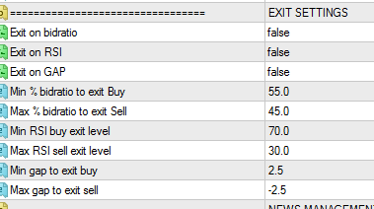
A very good idea Bernhard.... very good....
perhaps Jibala can also contribute 4-5 'possible' setfiles she'd like to see tested this week.. **hint,hint**
----------------------
Things to love about the NEW V3P
Attached Image
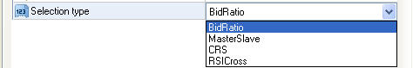
Attached Image
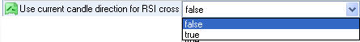
Attached Image
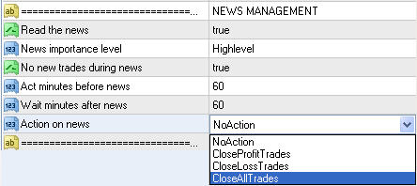
Flexi Filters:
Attached Image
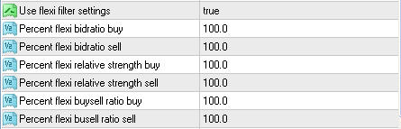
Flexi Filters:
FI: The bidratios are (now) based on the average above and below a cutoff point trying to follow the market a bit more.
FI: BUY bidratio average is (now) just those bidratios that are ABOVE 65% divided by the number of.
So.. If the bidratio for a certain pair goes above that average it is seen as a BUY signal
instead of using a fixed value like 80 or 90% of all 28 averaged (the old method).
Same goes for Relative strength and buy/sell ratio.
I added a selectable percentage for each value (in %) in case you get too many signals (go to 110%) or too few (go to 90%).
I would leave it at 100% for now (until it is tested).
3 Internal 'Dynamic' Exit Triggers:
Attached Image
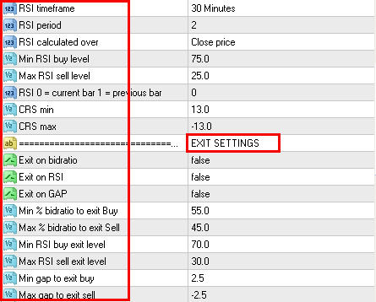
Attached Image
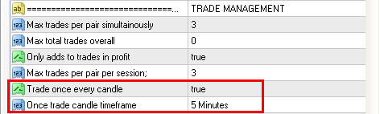
Signal and Trade Codes:
Attached Image
Signal filters
PRM = Primary filter (CRS,SYNC,Bidratio)
BDR = Bidratio
REL = Relative strength
BSR = Buy/Sell ratio
AS1 = ASH 1
MC1 = M Candle 1
AS2 = ASH 2
MC2 = M Candle 2
PDC = Previous daily candle
DOD = Daily Open Direction
GAP = GAP
Trade filters
HLT = Trading halted (ADR,News,Excluded)
SES = Outside session
STP = Stopped on #baskets profit/loss
LOT = No more available lots
MXT = Max trades per pair reached
TOT = Max total trades reached
MXS = Max trades per session reached
COR = Correlation found
OPS = In daily open save zone
S&R = In support/resistance zones
WDR = Wrong direction
OAP = Only add profit
MPD = Min pip distance
SYN = Sync filter
SPR = Spread
RSI = RSI
CAN = Once per candle
Things to Pay ATTENTION to:
Attached Image
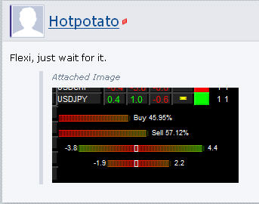
Attached Image
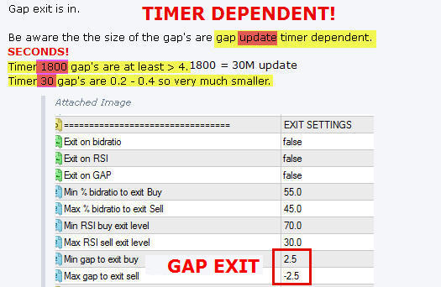
Attached Image
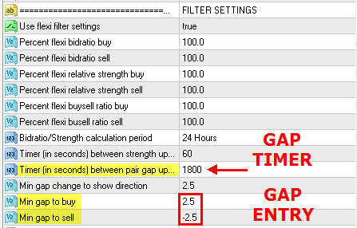

There are four (4) options you can take on trades when there is an upcoming News event via the News settings.
Attached Image
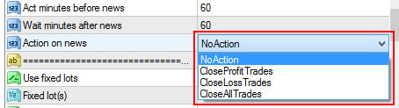
This is to 'help'... not 'explain' all.
The 'Dots':
The first 6 columns are the no-trade zones you can set in the settings.
DO daily open
PV daily pivot
R1-R2 daily restsistance
S1-S2 daily support.
CR is negative correlated pair detected when trying to enter a trade.
RV it is a reversed trade.
TR it is trailing the trade.
You basically look/analyze this ENTIRE BLOCK...
to
discern WHY a trade is NOT happening (yet)....
to help determine:
what/why you might want change: eliminate/add or increase/decrease in auto settings.
Attached Image
Signal and Trade Codes are found here.
On the Right Side of the Dashboard you find...
The Right-side Columns: Absolute Strength Values
Curr current pair strength
Prev previous pair strength
Diff the difference between them (GAP)
Dir direction of the difference (GAP) and only when exceeds the minium GAP settings on input
TZ trade zone (are we above or below the Daily Open)

