I Missed a few posts and I am sure you Sinus are working hard to adjust a few things_
The pin is very interesting and I think there is some little confusion with names and what is the main rule to follow_
Pls Sinus if you can make clear what is the strategy and the trigger to open trades_
Example you made a PIN name : 1.PIN_EAX_MANLINIER
With 3 Parameters :
------------------------------=================---------------------------------------
--MA NON LINIER –-------------------------------------------------
TF :
Length:
--DIRECTION---------------------------------------------------------
Tf :
Length:
--HI and LO –--------------------------------------------------------
TF_MA:
Ma Period:
------------------------------=================---------------------------------------
Then we have 3 Indicators which should be the corresponding Indicators, related
to the Pin Parameters and should be able to see on chart_
------------------------------]]]]]]]]]]]]][[[[[[[[[[[[[[---------------------------------------
MA_N_LINIER.ex4
Gan Non Linier.ex4 (Ma Non Linier Mtf Displays on Chart)
Gan Hi Lo.ex4
------------------------------]]]]]]]]]]]]][[[[[[[[[[[[[[---------------------------------------
What are the rules for this?
Do all 3 parameters need to align for a signal to be taken and a trade to be opened, right ?
…and how does it work ?
Normally the Gann HI/LO it is simple moving average of the previous 3 or 5? periods highs or lows. Are you considering this as the Trigger ?
And the Direction is the Ma N Linier ?
Do you want to take as main Direction a Higher Tf and then the entry trigger will be on lower Tf chart example H1 when the Price is above or below the MA n Linier ?
I would like to know how is this strategy, but if i can understand what those names means and to which function the parameters refer to then i can make my own... but i dont yet understand which one is which ,,, Direction Ma Linier ? Gann HI LO ?
Thank you for your patience explaining
Attached Images (click to enlarge)
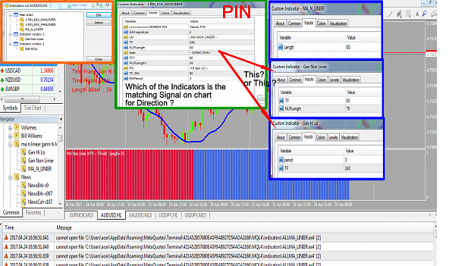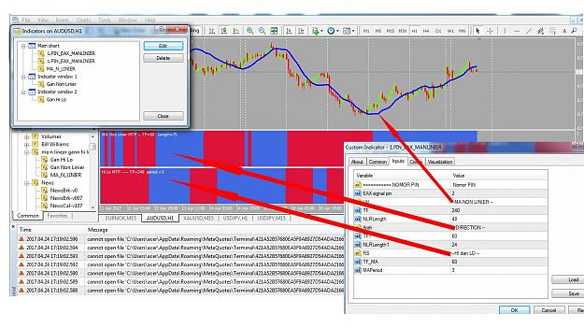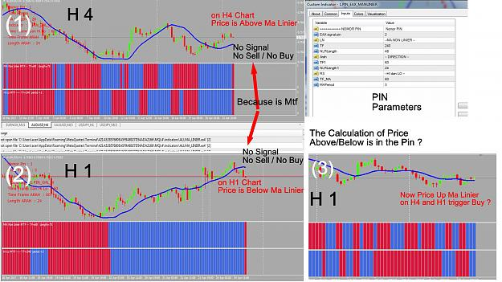
This image might be able to explain the Concept of the PIN...
Cheers....
Attached Image (click to enlarge)
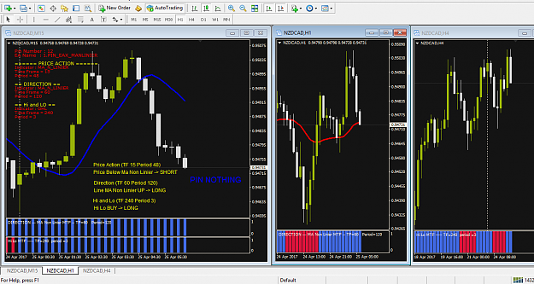

1

PIN EAX MA N LINIER...
This PIN and its Indicator ... and I have fixed it ...
I also include GAN Price Action, Direction and Hi & Lo to make easy observation on one chart ...
Cheerss......
Attached Files
1.PIN_EAX_MANLINIER.ex4 16 KB | 73 downloads
GHL.ex4 10 KB | 65 downloads
MA_N_LINIER.ex4 13 KB | 63 downloads
Gan Price Action.ex4 11 KB | 60 downloads
Gan Non Linier.ex4 11 KB | 67 downloads
Gan Hi Lo.ex4 10 KB | 63 downloads

1

