Thank you for this, It is CCFP-diff_V2.0
Pity i won't be testing any new Pins for this week
however pls allow me a small suggestion in photo, for those
who are not familiar with CCFP-diff
Nice one Sinus, I Luv Ccfp, great Tool from Ferrux 
Attached Image (click to enlarge)
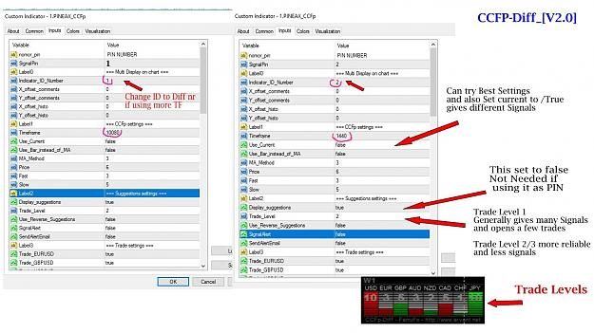
The trades taken by Pin Eax ccfp-diff are displayed on Eax on the pin nr you give to the PinEax
If you have the CCFp-Diff_[v2.0] Indicator
and then of course the 1.PINEAX_CCFp it must display 101 %
Need to see that if you display one Ccfp-diff only it is fine, and by default it comes with Id number 1
but if you want to display a second Ccfp-diff you need to change the Indicator Id Number in the parameters box_
For ex:
1st ccfp-diff on chart has Id Number (1)
2nd ccfp-diff on chart has Id number (2)
then you need to adjust x and Y ...
or try this set ... can change to trade level 2 .. now i am trying level 1
Attached Image (click to enlarge)
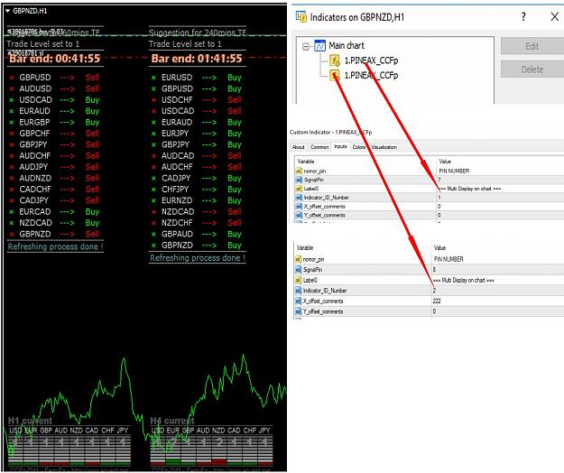
Attached File
PinEax_ccfp_sets.zip 1 KB | 84 downloads

=======================

THEORETICAL BASIS OF BUILDING CLUSTER INDICATORS FOR FOREX
13 July 2007, 14:04

SIMEON SEMENYCH
12
16 733

Introduction
Any financial instrument that is traded on the market is a position of some active towards some currency. FOREX differs from other markets only in the fact, that another currency is used as an active. As a result in the FOREX market we always deal with the correlation of two currencies, called currency pairs.
The project that started more than a year ago, helped to develop a group of indicators under a joint name cluster indicators. Their task was to divide currency pairs into separate currencies. Since then indicators were changed several times. Moreover, the interest of users and active discussions in forums allowed to develop methods of working with indicators and create trade systems based on them.

Operation Features of Cluster Indicators
The first distinctive feature of cluster indicators is in the fact, that for the operation they simultaneously need quotes of a certain group of currency pairs. The indicators can work with a separate currency pair, but in the author's opinion it is useless in practice. The advantage of indicators is exactly in the ability to analyse a large amount of currency pairs, dividing them into separate currencies. The more pairs they analyse, the more precise is the provided information.
In order to view fluctuation of three currencies, for example EUR, USD, GPB, we need quotes of three currency pairs: EURUSD, GBPUSD and EURGBP. And if you want to add for example JPY, you need quotes of GBPGPY, USDJPY, EURJPY - totally 6 currency pairs, where each currency has three relations with other currencies. Graphically it can be presented as a square with currencies on its angles, the relations (sides and diagonals of the square) between the currencies denote currency pairs. From each angle of the square a line will be drawn to all other angles. This self-contained net was called a cluster. It explains the name - cluster indicators.
As a rule, in the trading terminal MetaTrader 4 indicators are shown in a separate subwindow under a price chart and their form depends on the currency pair examined. In their turn cluster indicators look like the same everywhere, no matter to what chart they are connected. This is the second distinguishing feature of the cluster indicators. Picture Fig 1 shows the indicator CCFp (Complex_Common_Frame percent). In spite of its binding to the chart EURUSD, it will have the same form on any other currency pair, even if this pair doesn't belong to the analysed cluster.

Basic Concepts of Working with Cluster Indicators
In the picture Fig 1 there are eight lines of different color. Each line corresponds to a definite currency. Cluster indicators reflect not the currency indexes, but their fluctuation relative to each other. Indicators represent a self-contained system; this makes the market model simpler, but such simplification does not hinder a successful trading on the indicators.
The currencies are measured in relative units, that is why in each unit time the sum of all currencies will be equal to zero. Thus one of the basic elements of cluster indicators is a zero line, or balance line. If a currency is below the balance line, it is said to be oversold as compared to other currencies. Accordingly, if a currency is above the zero line, it is said to be overbought. If a currency is overbought, sooner or later it will start to wind down against all other currencies, the currency line will go down and may reach the balance line or even enter the overselling zone.
The nearness of a currency to the balance line means that the currency is in the balance state towards other currencies. One more important element of cluster indicators is the point of intersection of lines, pointing to the trend change or giving a signal. Besides, based on indicators one can extract divergency and convergency, but we will discuss these elements in details in the next article "Practical application of cluster indicators in the FOREX market".
I would like to draw your attention to a fact, which is not evident during analysing cluster indicators. Usually indicators are build on the basis of the price of a definite currency pair. But cluster indicators are build on the basis of all currency pairs of the complex. Watching the indicator you must understand that we observe the prices of all the twenty four currency pairs simultaneously, and not only the derivative from the price of a current currency pair, to which the indicator is attached.
If the indicator is displayed under the pair EURUSD, beside this currency pair it calculates pairs EURGBP, USDGBP, USDCHF, EURJPY and so on, i.e. all other pairs, which include USD and EUR. And when a trade signal comes, you must remember, that not a definite pair is traded, but the whole market, or a market cluster to be more precise. This fact is an advantage, but at the same time a disadvantage. Signals on this indicators are more secure, because they are build on the basis of all currency pairs. But at the same time there is always a risk, that the chosen currency pair will stand out among the whole complex of currencies. For example, in the market it may happen so, that large amounts of pounds are sold for USD. The influence of one currency on the whole cluster is a little more than 4% (onу pair out of twenty four). In this case the indicators are most valuable as informational, not trading. Though trading systems are created based on the indicators.

Requirements for Cluster Indicators Operation
Terminal MetaTrader 4 makes some restrictions, which do not allow to use cluster indicators for all financial instruments. The maximal number of lines on the indicator is eight. That is why the largest cluster can contain only eight currencies. This set includes: USD, EUR, GBP, CHF, JPY, CAD, AUD, NZD. And for their operation the indicators need quotes of twenty four currency pairs: EURUSD, EURGBP, EURCHF, EURJPY, EURCAD, EURAUD, EURNZD, GBPUSD, GBPCHF, GBPJPY, GBPCAD, GBPAUD, GBPNZD, USDCHF, USDJPY, USDCAD, AUDUSD, AUDJPY, AUDCAD, AUDNZD, NZDUSD, NZDCHF, NZDCAD, NZDJPY. The necessity of the quotes on the indicated pairs until recently was limiting the number of brokerage companies, on whose platforms the indicators could operate.
Nowadays in the last indicator modifications the requirements became lower, now you need to have all crosses that include USD. So , to have indicators operate, the following currency pairs are enough: EURUSD, GBPUSD, USDCHF, USDJPY, USDCAD, AUDUSD, NZDUSD. As the author knows, all brokerage companies working on MetaTrader 4 platform provide quotes for the mentioned currency pairs. But it must be remembered that old versions of indicators, which still can be met in the Internet, request the complete set, i.e. twenty four currency pairs.
It should be noted, that cluster indicators, especially those of earlier versions, were very demanding to the computer capacity and the capacity of the Internet Channel. Now the requirements are lower, however cluster indicators remain more resource-intensive than the majority of other indicators and oscillators. Besides, experience shows that primary installation of the indicators generally reveals the deficiency of quotes on some currency pairs, which suggests their forced downloading.

Types of Cluster Indicators
During the development of the complex of cluster indicators, a large number of ideas was realized in separate indicators. However now the author suggests dwelling on three main types.
The first one is indicator CCFp, it is shown at the picture Fig 1.
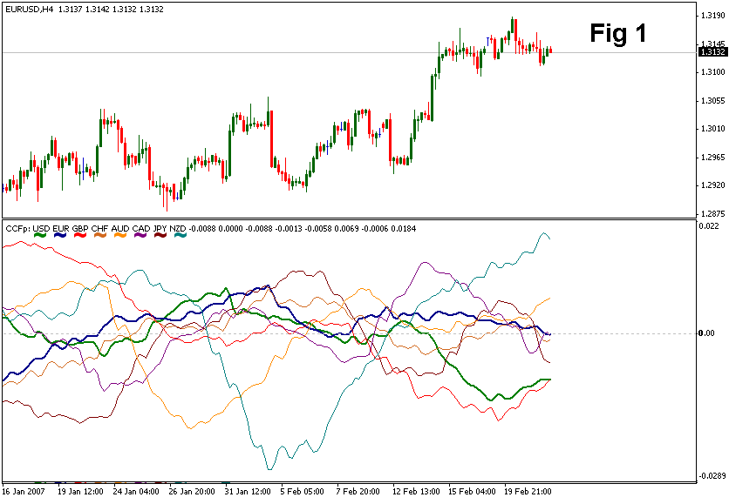

CCFp (Complex_Common_Frames percent) – is a trend following indicator. Its predecessor CCF estimated the divergency of currencies in points, while CCFp works with specific values, which allows to avoid distortions, resulting from the "heaviness" of separate currencies. "Heaviness" here means that, for example, pound is almost twice more expensive than USD (Febr. , 2007 - time of article writing). As a result - points for each currency have different value. So the decision was made to count the percentage.
The second indicator is CC (Complex_Common).
It is an impulse, or signal indicator. It is very sensitive and quickly reacts on the price movements. The indicator is shown at the picture Fig 2.

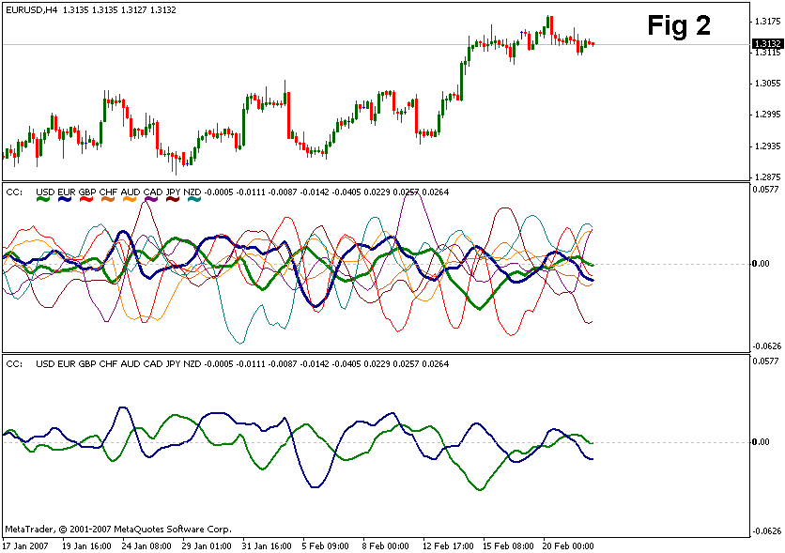

The picture shows the currency pair EURUSD. Two windows below contain the same indicator. The upper window shows all the currencies, lines of USD and euro are semi-bold. The lower window contains the same indicator, but all other currencies are concealed; it shows currencies only of the corresponding pair.
The third indicator Complex_Pair1
is a derivative from the indicator CC. At the picture Fig 2 the lower window displays only two lines: EUR and USD. The sum of these indicators is the indicator Complex_Pair1, which reflects only one impulse (signal) line. You can see this indicator at the picture Fig 3.

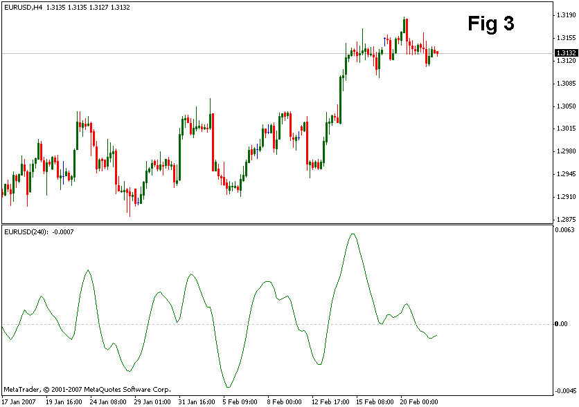

It should be noted, that the indicator Complex_Pair was developed first. But it was too resource-intensive. Later development found another way of building the same indicator, but using a fast algorithm, which allowed to extract the same information, but now from the price chart of one currency only. Inspite of the fact, that Complex_Pair and Complex_Pair1 receive the information in different ways, their visual identity on the higher timeframes was absolute. On the lower timeframes there was some difference, but Complex_Pair 1 can work on any financial instrument - stocks, futures or raw material.
The author of the cluster indicators specifies, that the algorithm of the indicator Complex_Pair1 was developed by another person. (Forum of the site Onix, developer - arzuma, link to a message).

A Short Description of Algorithms of Cluster Indicators Operation
The idea of dividing a complete cluster of currency pairs into separate pairs is simple. Suppose, a small cluster is used for currency pairs EURUSD, GBPUSD, EURUSD and the task is to separate the currencies: EUR, USD, GBP. If within a certain period of time a pair EURUSD grew, the difference will be added to EUR and subtracted from USD. If at the same time the pair GBPUSD raised, the changes in price are added to GBP and subtracted from USD. And, finally, it is necessary to consider the price changes of the pair EURGBP. Suppose the pair sank, then the difference will be added to GBP and subtracted from EUR.
As in Forex it is impossible to determine a common denominator, which could be a model stable in time, when separating currencies, they are not normalized and all the changes are counted in relative units. Until recently a point was accepted as such unit. But as the point value is changeable in time and is different for different currencies, in last modifications of cluster indicators the price change was calculated in percentage. Besides, experience showed that contemporary quote servers do now allow a significant difference of currency crosses. That is why to reduce the traffic of pumping quotes and to increase the operation speed of the indicators, calculations of all currency pairs are conducted on the basis of dollar crosses only. So the general algorithm of the indicators looks like this:
- Determination of currencies, that will enter a cluster. Is set by user's settings;
- Mathematical calculation of non-dollar crosses based on dollar ones, even if USD is excluded from the cluster;
- Noise filtering by moving average. The parameters are set by the user;
- Analysing all currency pairs of the cluster on the price change and fulfilling the matrix of currencies, included into the cluster;
- Next is the logical realization of a certain type of indicator, i.e. for a trend following indicator several timeframes are processed (not only the current one), simple transformations are used for an impulse indicator.
The source files of the indicators CCFp, CC, CFP, Complex_pairs1 are attached to the article.

Parameters of Cluster Indicators
The following inputs available for setup are determined in the last version of the indicators. The inputs are divided into several groups.
The first group of inputs determines the method of filtration
MA_Method - method of determining a moving average, can be one of the following variants:
- 0 - Simple moving average;
- 1 - Exponential moving average;
- 2 - Smoothed moving average;
- 3 - Linearly-weighted average.
The parameter 3 is set on default
Price - used price, can accept one of the following values:
- 0 - Close price;
- 1 - Open price;
- 2 - Maximal price, (High);
- 3 - Minimal price, (Low);
- 4 - Average price, (High+Low)/2;
- 5 - Typical price, (High+Low+Close)/3;
- 6 - Weighted closing price, (High+Low+Close+Close)/4.
The parameter 6 is set on default.
Fast - a period of fast average, on default - 3.
Slow - a period of slow average, on default - 5.
The second group of inputs enables to form different types of clusters
This group encloses eight logical parameters, which can assume a value true/false (1/0). Each parameter includes this or that currency into a cluster or disables it:
- USD - includes into the cluster or excludes from the cluster US dollar (on default - true);
- EUR - includes into the cluster or excludes from the cluster Euro (on default - true);
- GBP - includes into the cluster or excludes from the cluster British pound (on default - true);
- CHF - includes into the cluster or excludes from the cluster Swiss frank (on default - true);
- JPY - includes into the cluster or excludes from the cluster Japanese yen (on default - true);
- CAD - includes into the cluster or excludes from the cluster Canadian dollar (on default - true);
- AUD - includes into the cluster or excludes from the cluster Australian dollar (on default - true);
- NZD - includes into the cluster or excludes from the cluster New Zealand dollar (on default - true).
The third group of inputs manages the external view of the indicators
It should be noted, that line thickness and color should be better set through this inputs, and not through a common tab, present in any indicator. When a line is set up in an invisible color (background color), the lines will not be displayed on the indicator, but currencies will be calculated. A currency can be excluded from the cluster only through the second group of inputs, described earlier.
- Color_USD – color of a line for US dollar;
- Color_EUD – color of a line for Euro;
- Color_GBP – color of a line for British pound;
- Color_CHF – color of a line for Swiss frank;
- Color_JPY – color of a line for Japanese yen;
- Color_CAD – color of a line for Canadian dollar;
- Color_AUD – color of a line for Australian dollar;
- Color_NZD – color of a line for New Zealand dollar;
- Line_Thickness – presets the line thickness of a displayed currency pair. Sometimes it is convenient. For example, if we analyse the chart EURUSD, it is more convenient when EUR and USD differ from others not only in color, but also in the line thickness.
At the same time the indicators can be set up so, that other currencies will not be visible at all; only necessary currencies will be viewed. The example of such setting is at the picture Fig 3.
The fourth group of inputs includes only one parameter, but now there is an idea to include additional parameters into this group.
All_Bars determines the number of the calculated history bars. If this parameter is equal to 0 (it is so on default), all available history is calculated. But, as mentioned earlier, the indicators are resource intensive, that is why its use on low-performance computers is problematic. This parameter allows to unburden the machine by limiting the analysed history of quotes. It is noted, that at values 1000 and 500 the operation speed of indicators is significantly higher.

Conclusion
The advantage of cluster indicators is in their ability to show in one window dynamics of relative currency fluctuation, which allows to discover promising currency pairs, which are likely to experience trend movements. Cluster indicators allow to track trends inception and can give signals to open or close positions. You can find more information about the operation of indicators from the article "Practical use of cluster indicators in FOREX market". You can read about the history of development of indicators on the site Onix, section "Cluster indicators".
Translated from Russian by MetaQuotes Software Corp.
Original article: https://www.mql5.com/ru/articles/1464
Attached files |
Download ZIP
CC.mq4 (16.97 KB)
CCFp.mq4 (17.15 KB)
CFP.mq4 (13.82 KB)
Complex_pairs1.mq4 (3.67 KB)

PRACTICAL APPLICATION OF CLUSTER INDICATORS IN FOREX
3 September 2007, 15:30
SIMEON SEMENYCH
9
18 774

Introduction
In the article "Theoretical Basis of Building Cluster Indicators for FOREX" we analyzed the operation principle of cluster indicators. The article also introduced main definitions: "overbuying", "overselling" of currencies and balance line. In this article we will dwell on the practical application of indicators. The article includes a number of tactical and strategical methods of trading on them:
- methods, helping to detect potential pairs, on which trends may start;
- procedures of defining entry and exit times;
- methods of tracing long-term and medium-term positions.
Examples here contain the full cluster, consisting of eight currencies. In practice you can develop any cluster, for example, you can omit primary currencies or currencies, the information on which is excessive for your own trading system. Besides when working with cluster indicators, take into account that they provide information on the basis of all currencies, included into the cluster, and not only currencies of the analyzed currency pair. This factor sometimes distorts useful information. Still signals, received from the indicators, are considered more reliable, because they take into account price fluctuations of all currency pairs, and not only of the analyzed one.

Projection of Main Elements of Price Charts onto Cluster Indicators
The price chart contains periods of trend, consolidation periods (flat) and pivot areas. Cluster indicators, like any other indicator, reflect prices; that is why they cannot forecast future directions and pivot points. But on the other hand the behaviour of cluster indicators differs much from the majority of classical tools; that is why they may display the information about prices, which is not very evident when using other indicators.
In examples we used such indicators as CCFp and CCp. These indicators have up to eight information lines, each of them corresponds to a certain currency. Very often in analysis it is interesting to view all lines, but in the examples the lines of currencies, not included into the analyzed pair, will be hidden for better attention to the necessary information. Fig 1 displays one and the same indicator CCFp for the pair EURUSD, but in different forms. The upper indicator reflects all currencies included into the cluster. The one below is the same cluster, consisting of eight currencies, but visible are only lines of EUR and USD, other lines are hidden. It is possible due to the indicator settings (See the article "Theoretical Basis of Building Cluster Indicators for FOREX").
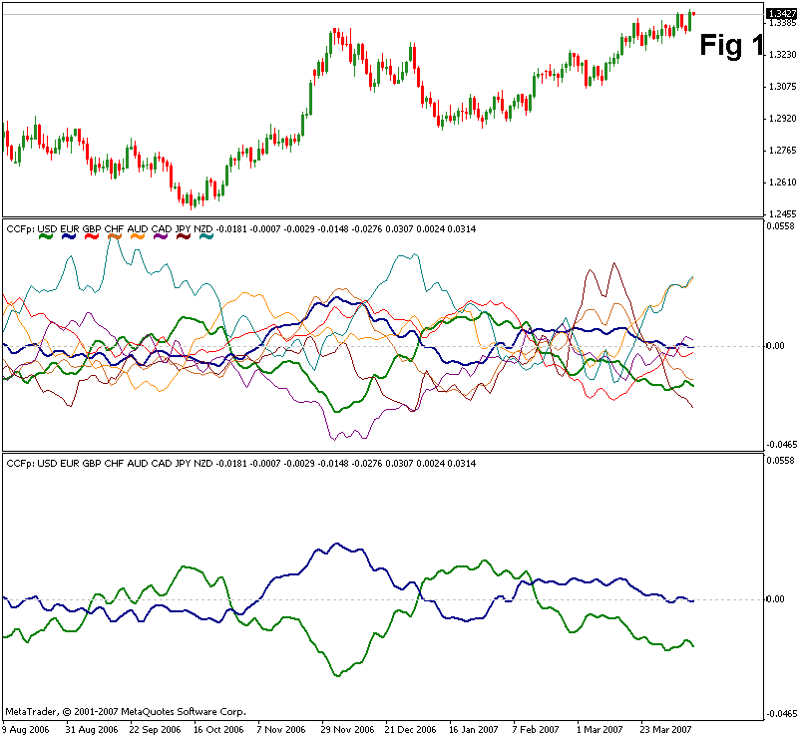

Trend Change
Any price chart reflects the periods of uptrend and downtrend. And the main task of cluster indicators is to determine the change of the direction. There are two types of cluster indicators: trend-following and impulse (or signal). Each type has two modifications: complex, which reflect all cluster currencies, and pair, intended only for a chosen pair. Let us analyze each type.

Impulse (Signal) Indicators
This type includes indicators CCp and Complex_pairs (Complex_pairs - original, Complex_pairs1 - light version). The picture Fig 2 displays Complex_pairs1 (upper one) and CCp (lower one). The indicator CCp displays only two currencies - EUR (blue line) and USD (green line) - other currencies are hidden, though they take part in the cluster. If in this indicator one currency is higher than the other one, it is considered to experience growth relative to each other. When the lines intersect, the balance of the pair currencies is achieved. As a rule, the achievement of the balance point shows that the direction will probably change, i.e. a signal appears.
This indicator not always shows, whether the currency lines intersected or not. For a better visualization of this moment, and for strengthening an amplitude, the indicator Complex_pairs is used. In it the intersection of a signal line with a balance line will coincide with the intersection of currency lines in the indicator CCp. In Fig 2 vertical lines are drawn through the points of intersection of the indicator Complex_pairs with the zero line, and with points of intersection of currency lines in the indicator CCp. All intersections take place in one and the same moment of time.
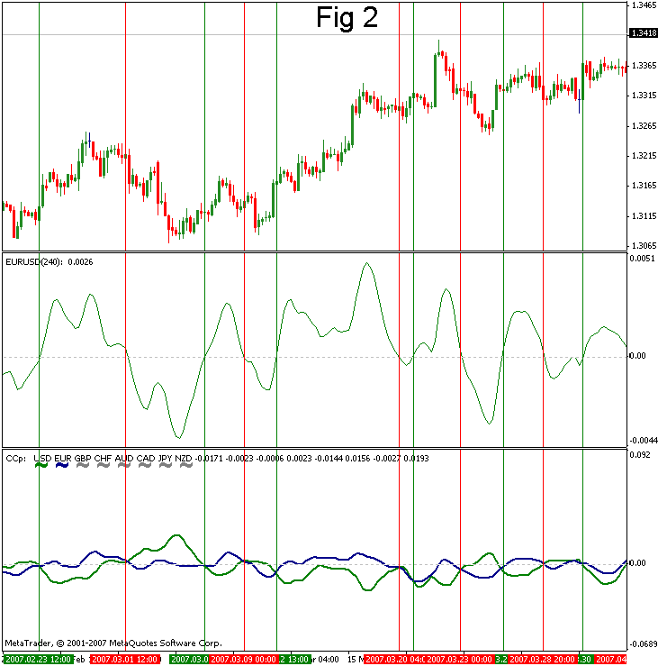

Red vertical lines are drawn in the moment, when a bear signal on the pair EURUSD comes. In the indicator Complex_pairs it is the intersection of the signal line with the zero line downwards, and on the indicator CCp it is the moment, when the dollar line is above the euro line. Green vertical lines give the bull signal for the pair EURUSD. However one cannot use signals produced by impulse indicators directly in trading. In trading it is necessary to take into account the general direction of the pair's movement. For example, one cannot follow signals, which are against the trend. To determine the general direction of a trend either higher timeframes are used, or trend following indicators are analyzed.

Trend-Following Indicators
This type includes two indicators (See Fig 3): CCFp, which reflects two currencies, and others are hidden, and the indicator CFP, adjusted to the given pair EURUSD. Like in impulse indicators, intersection points of CCFp indicator lines coincide with the intersection of the indicator line with the balance line. As distinct from signal indicators, trend-following indicators do not give trade signals, but they show the general trend, i.e. point out, which signals are more preferable at this moment of time - bull or bear.
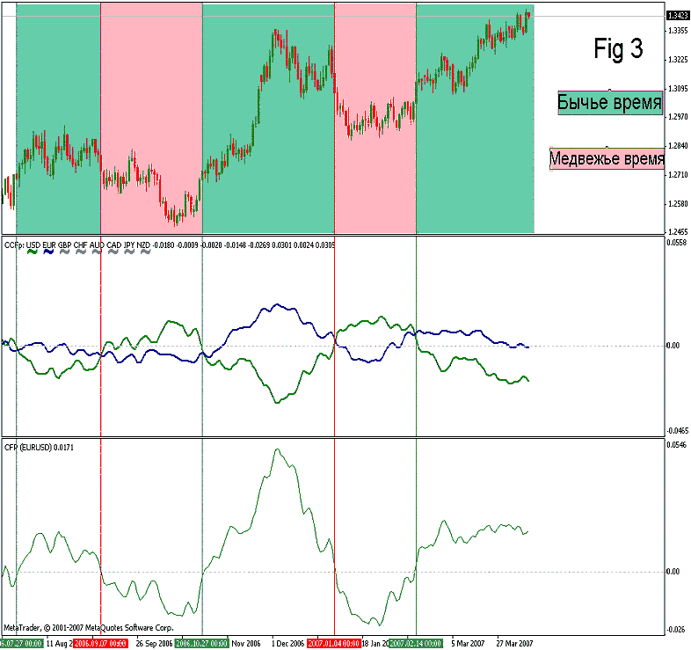

In Fig 3 such periods of time are marked out. Green areas are periods, when it is more preferable to process bull signals, red areas are bear periods. While trend-following indicators take into account the influence of higher timeframes, they have inertial character and that is why they show the trend change later than other indicators. But at the same time, due to this inertance and dependence on higher timeframes, these indicators show pivot points more exactly. But we will discuss it later, when analyzing trading by indicators. And now let us see, what information is presented by the balance line.

Balance Line
The total sum of all currency lines on the indicators CCFp and CCp in each time unit is equal to zero, irrelative of the amount of currencies in a cluster. So the indicators described reflect not only the mutual fluctuation relative to each other, but also the fluctuation relative to zero. If a currency line is above the zero line, it is said to be "overbought", if it is below the zero line, it is said to be "oversold".
When a currency is in the zero line area (balance line), it does not experience tension, being in the equilibrium point. The further movement from the balance line will depend on the fact, whether the currency will be sold or bought. On the other hand, when a currency line is in the overbought area (above the zero line) or in the oversold area (below the zero line), the occurring tension forces the currency to return to its balance state - zero line. While in practice we deal with currency pairs, we always have to analyze the dynamics of two pairs. For this purpose there are special indicators CFP and Complex_pairs, which also have the balance line, and the signal line is the sum of two currencies.
Exactly the same way the zero line in these indicators will show, when the currency pair is in the balance state, and when it experiences this or that tension. Projection from the intersection of indicator lines with the balance line can point out the price, around which the currency is fluctuating, thus determining the periods of flat or trend. At the pictureFig 4 blue vertical lines are drawn through the intersection points of the indicator lines. They allow to determine the equilibrium price for the pair EURUSD. Thus, we can transfer the balance line onto a price chart (purple line). Actually there is a special indicator Complex_balance, which allows to do it automatically. But analyzing this indicator is outside the topic of this article. You can find more information about it on the site Onix.
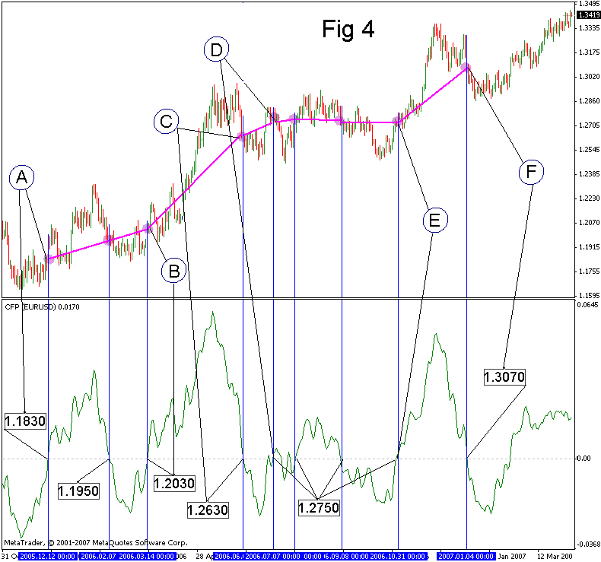

The horizontal balance line on the price charts shows that the currency pair is in flat. If it is sloping, the pair is in trend. Thus, for example, the period between A and B is determined as a trend. The period BC is a strong trend, and CD is its fading. After that in the period DE the pair was in consolidation, and in the period EF we see a new trend on the pair EURUSD.

Tactical Trading Techniques with Cluster Indicators
To tactical techniques we refer trade signals for short-term and medium-term trading, as well as determination of the nearest levels, which can be used for setting targets and stop signals.

Trading Using the Balance Line on a Chart
As an example we will analyze the pair EURUSD and the same timeframe, described earlier. The initial position is the presence of points A and B, which show that the price is in trend, and two levels of price range on a chart - 1.1635 and 1. 2320 (See Fig 5).
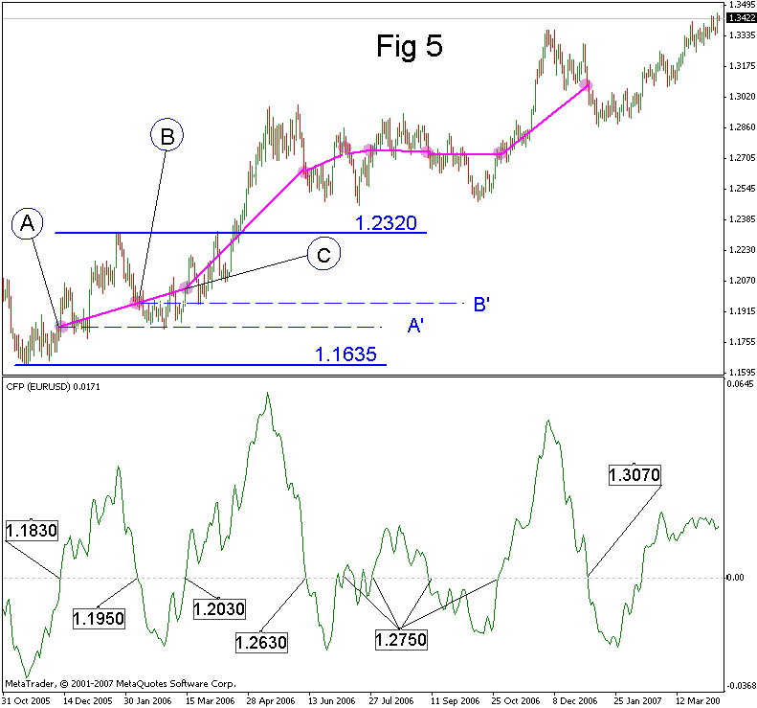

Two horizontal dotted lines are drawn from points A and B. In future they will give support to the uptrend. You can buy starting from these lines in the direction of the uptrend. We buy from the line A' until point C appears. After that we expect the price to return till the line B'. While the point C proved the continuation of the trend, buying from the line B' is appropriate. After the point C we expect the appearance of the next point D and returning to level C' (See Fig 5a).
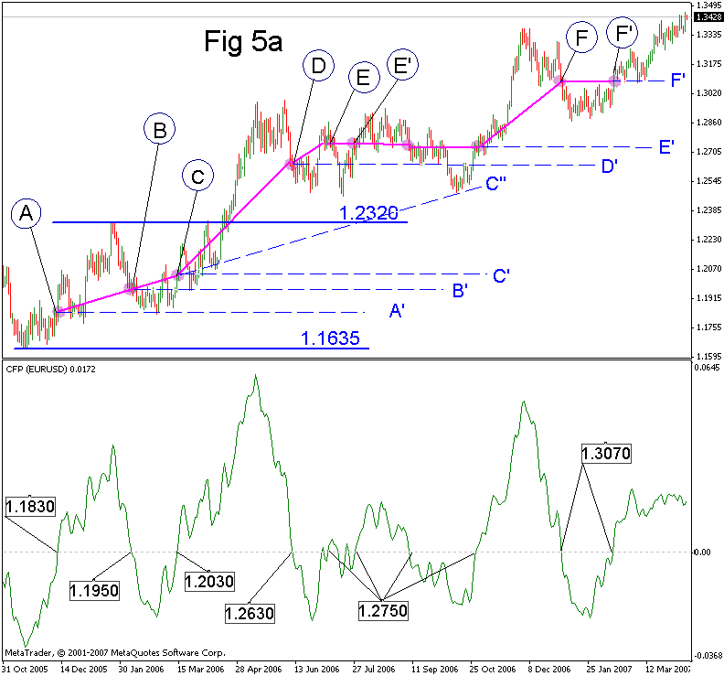

But this returning did not happen, because the trend became stronger and the point D appeared much higher than we expected. The only trend support at this moment can be the continuation of ABC trend main line - line C''. This support was used, but after the pair consolidation period (DE in Fig 4), still a trend continued due to this support. We see, that after the line E appeared, the balance line changed its slope - the trend diminishes and the failure of the support of D' is quite probable, what actually happened and the confirmation is the following: the next point E shows there is no trend any more. The consolidation period will be over only after testing the line C'', from which a trend can be renewed or, in case of its failure, we expect the fall of the pair till C'. The history shows that the trend continued (See picture Fig 5a). The appearance of the point F’ shows that the trend slows down. At the present moment of time we expect the formation of the next point. The functioning supports of the trend are C'', E', F' (information at the moment of writing the article). If the pair trend changes downwards, the target may be the line C', from which the price could not move upwards.

Trading Using Impulse Indicators
In trading on a separate currency pair the indicator Complex_pairs is used. First, general definitions (See Fig 6).
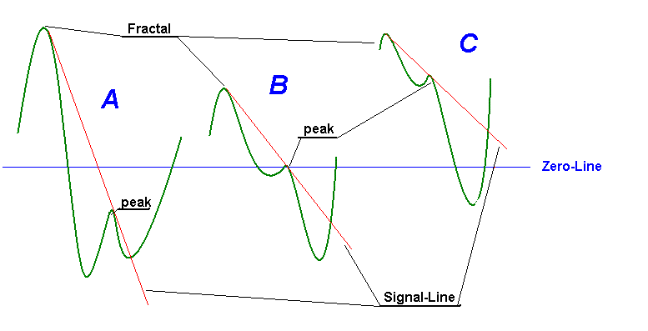

For determining a signal we need a clearly expressed Fractal - a sharp peak, which, as a rule, appears after strong movements. The second element is the presence of a subsidiary (supporting) peak. From a fractal through this peak a signal line (a red line on the picture) is drawn. When the indicator line crosses a signal line, an aggressive signal appears. At that, if the fractal was above a zero line, and the intersection was below it, this is a signal to buy the pair analyzed.
This aggressive signal will be confirmed, when the indicator line crosses a balance line. Trading may be different: you may buy at an aggressive signal, and add or move the stop into lossless area. And sometimes you may act in a conservative way and process only confirmed signals. Besides signals differ in their strength. In Fig 6, variant A is a strong signal, the probability of its processing is very high. Moreover its potential is much higher than that of other variants. Variant B occurs much oftener than variant A, but the signal itself is much weaker, because the subsidiary peak is in the balance line area. The third variant C is the weakest one. As a rule it is more likely to produce loss than profit. The difference from the previous variants is the following: the intersection of the indicator line and the balance line happens earlier, than crossing the signal line.
It happens so, that the indicator line after crossing the signal line goes down, causing divergence. Such signal is considered to be the strongest one, but it happens not very often. Let us view a practical example - the pair USDJPY is used to show not only successful entries, but unsuccessful signals as well. In Fig 7, signals are produced by the indicator Complex_pairs (original). Timeframe is H4. We analyze signals only for variants A and B, because variant C is very weak.
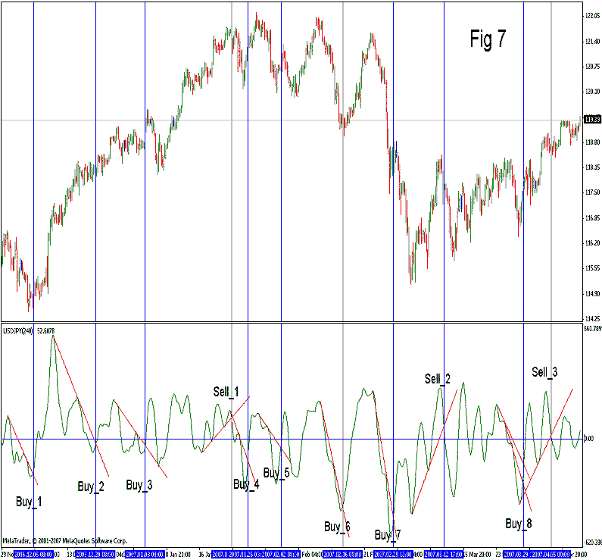

Red signal lines are drawn from a fractal through a subsidiary peak till the intersection with the indicator line. The intersection point gives an aggressive entry signal, Buy_N signals to buy the pair, Sell_N - signals to sell the pair. Through the intersection points vertical lines are drawn; they help to see the entry points on the price chart. The first signal to buy the pair (Buy_1) is very strong, because the subsidiary peak is in the oversold zone. The signal Buy_2, is weaker than the previous one, inspite of the fact, that the fractal itself is quite high, but the subsidiary peak is above the zero line, though the signal point is below the balance line.
The same is with the signal Buy_3. But it is even weaker because, the fractal is not very high and the signal line is very close to the balance line.
The signal Sell_1 is very strong, even though there is a small peak, but it has two subsidiary peaks. Here we need to make one note. The signal comes after the signal line crosses the balance line. You cannot trade by expectancies (open a position before the intersection point, hoping that there will be such an intersection), because the indicator line may move aside and not cross the signal line, or may fail to reach it (See the signal Buy_8). The signal Buy_6 is a very strong signal, like Buy_1. And the same as Buy_7. But exactly Buy_7, despite that it is a very strong signal, did not function, moreover the movement in the opposite direction was very impetuous. That is why any system needs predetermined levels of stop signals.
Talking about the indicator Complex_pairs, I would like to mention that it has a light version Complex_pairs1. Their behaviour is almost identical on higher timeframes, but differs on small ones. However Complex_pairs1 may operate with any financial instrument, including stocks, futures and raw materials.

Strategical Trading Techniques in Cluster Indicators
Strategical trading using cluster indicators consists of determining a potential of new trends formation, entering ling-term positions and their tracing. As a rule trend-following indicators CCFp and CFP are used for these purposes.

Searching Promising Currency Pairs
Not very often, but from time to time there are such moments in the cluster, when the generation of a new trend is expected. In Fig 8a you can see both indicators CCFp (with all currencies) and CFP for the pair EURUSD (daily timeframe).
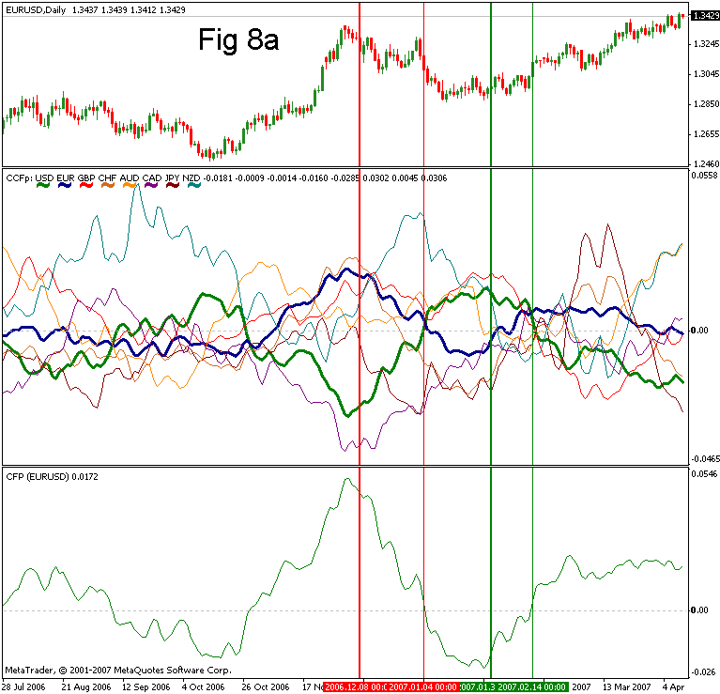

The advantage of these indicators is the following: if a currency starts falling it is likely to continue falling due to the inertial character of such indicators. The same is with the pair indicator CFP. In the picture there is a potential for the pair EURUSD to fall, it is marked with a thick red vertical line. This line is shifted from peaks to make sure that euro started falling and USD experiences trend, and the pair EURUSD started falling. It is not seen on peaks in real trading. But in medium-term and long-term meaning it is not so important to catch the peak, because anyway we expect enough profit for not trying to catch a new trend from the pivot point.
From the thick red line till the thin red line we see the formation of a new trend, the intersection of currencies on the upper indicator and crossing of the balance line on the lower one prove that the trend has changed. Usually after an intersection point strong movements appear, i.e. a trend starts. As a rule, the trend movement causes the reverse tension of currencies - the potential changes its sign. The thick green line shows the appearance of a potential for the rise of this currency pair, and the thin green line in the intersection point hindered the trend change. But while the potential was not very strong, the movements are not very impetuous. However such movements usually last longer.
Now let us view the pair GBPJPY (Fig 8b). We have chosen this pair first because the potential is relevant at the time of writing the article. Second, here we see convergence on both - Pound and Yen. I.e. a signal came earlier, but the currencies drew additional peaks against this potential, which caused formation of bull convergence on this pair. Quite a rear case, it is convenient, because it allows to strengthen the position, opened earlier.
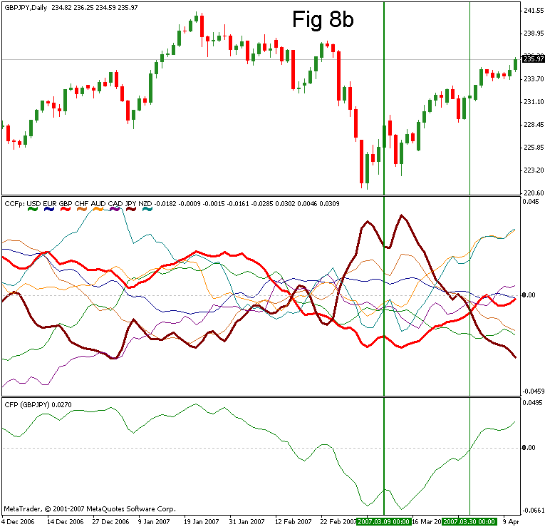

Tracing Long-Term and Medium-Term Positions
When medium- and long-term positions are opened, it is necessary to take certain steps, considered to be position tracing. Monitoring of a general direction is controlled by trend-following indicators. A position is closed, when reverse potential appears. Before this you do not always need to close positions fully, because very often one currency changes its direction, while the other currency continues the main one. In such periods currency pairs may be in flat or perform corrections. Accumulation of a position, i.e. opening in the direction of earlier opened positions, may be performed using signal indicators. It is convenient, because stop-signals in this case will be much higher than in intraday trading. The same way using impulse indicators we may fix profit, when signals opposite to the main movement come, or open opposite positions aiming at getting backout or correction without closing main positions.

Conclusion
In conclusion I would like to dwell on the question of indicator parameters. They were set for the cluster of eight currencies. If a smaller cluster is used, for example primary currencies are excluded, the parameters can be set more precisely. Besides, the parameters were preadjusted for timeframes higher than H4. If your trading system uses smaller timeframes, the parameters should be adjusted according to your trading system.
It should be also taken into account, that the indicators can be made more sensitive. In this case they will produce signals earlier, though the amount of false signals will be larger. Or on the contrary they can be made more inertial. In this case signals will be rear and come later, but their reliability will be higher. Thus it is recommended to change the indicator parameters not only according to your own trading system, but also taking into account your trading mode and, if necessary, your temperament.

Translated from Russian by MetaQuotes Software Corp.
Original article: https://www.mql5.com/ru/articles/1472
Attached files |
Download ZIP
CC.mq4 (16.97 KB)
CCFp.mq4 (17.15 KB)
CCp.ex4 (19.41 KB)
CFP.mq4 (13.82 KB)
Complex_pairs1.mq4 (3.69 KB)

